19th March 2014

Media Release
Monitor the Sparrows this March
World Sparrow Day secretariat registers activities from around the world

Fifth Year of World Sparrow Day
Sparrow populations in many countries around the world are declining. World Sparrow Day on 20th March is everyone’s chance to rise to the challenge of saving them.
The humble house sparrow is one of the world’s most common and widespread species. Apart from the house sparrow, there are other twenty-six distinct species of Sparrow. World Sparrow Day is an effort to create awareness about all these species which are spread across three continents namely Asia, Africa and Europe.
The theme for this year is “Monitor the Sparrows & other common birds” and the World Sparrow Day secretariat is urging people to monitor Sparrows and other common birds this year using the Common Bird Monitoring of India, a citizen science initiative of Nature Forever Society.
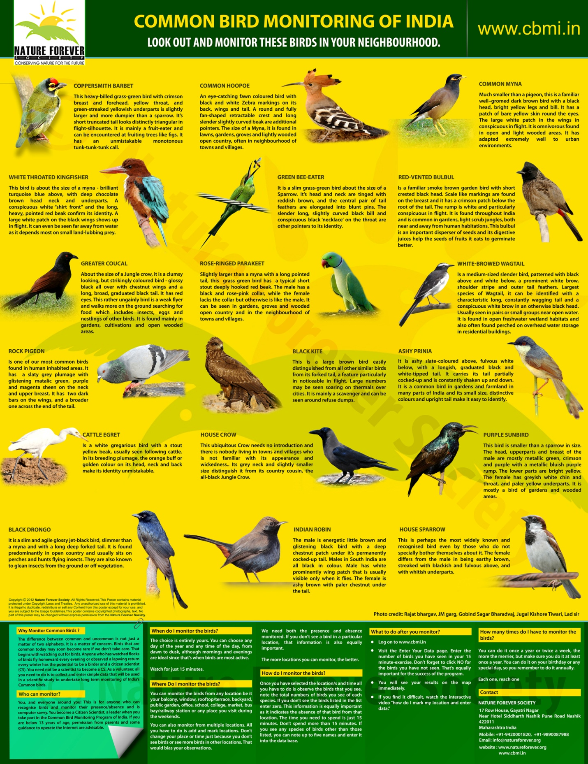
The secretariat urges citizens and organisations to register their events on www.worldsparrowday.org helping citizens at local level to get associated with it. We have received more than 45 events registered from across the globe on World Sparrow Day events map. In addition, the organizers would be sending post-event information to the secretariat which will help in compiling events’ report organised across the globe.
We request citizen to share information on events conducted to be shared via our website www.worldsparrowday.org |www.natureforever.org |www.cbmi.in |
Wipro has been supporting World Sparrow Day for the past four years and is committed towards the conservation of lesser known species and issues related to conservation.
Wipro-Nature Forever Society Sparrow Awards
The Wipro-NFS Sparrow Awards were instituted in 2011 with an aim to identify citizens who are an inspiration for the Citizens to get involved into conservation. Since last year, a cash prize of Rs.50,000/- are given to each of the three Sparrow Awardees to support them financially in their endeavours.
The funding will help the winners carry out vital conservation and environmental work undertaken by them. It will also help inspire citizens to get involved in conservation movement of India. Nature Forever Society is committed to helping the winners in continuing their positive environmental and conservation efforts.
The Wipro - Nature Forever Society Sparrow Award are not given to professional conservationists, ecologist or environmentalists. It is given to citizens who are doing innovative, inspirational and grassroots’ work towards conservation and environment.
Our sentiments behind the awards
We have often noticed that in the field of conservation while the best known conservationists consistently receive accolades for their work, there is no support offered to the citizens carrying out grassroot conservation work in their local regions.
We believe that such citizens whose job or profession is not conservation, but are making vital and important contributions in a selfless right way to save the environment, deserve accolades. The sentiment behind Nature Forever Society’s Sparrow Awards is to honour such people and applaud their silent efforts.
In the coming years, we aspire to make the Wipro – Nature Forever Society Sparrow Award one of the most prestigious honours one could hold; tough to attain and inspirational to retain.
Objective behind Wipro - Nature Forever Society’s SPARROW AWARDS:
- To involve the citizens from diverse sections of the society in the conservation movement
- To honour the work of individuals and organisations at the grassroots level for strengthening the conservation movement for protection of the environment and biodiversity.
Since its inception in 2011, Awards have recognised inspirational work of citizen non- professional conservationists and researchers.
Wipro – Nature Forever Sparrow Award 2014winners were selected through information collected from different sources throughout the year as well as through nominations received from across the country. The credentials of all candidates were further scrutinised and authenticated.
Nomination process for this year’s awards were closed on 15th February 2014. What followed was a gruelling selection process, creating a shortlist of nominees meeting the key criteria, the work should be innovative, inspirational and that individuals are suitable role models for the citizens to follow.
Three individuals from different parts of the country were selected as outstanding recipients of the Wipro – Nature Forever Society Sparrow Awards 2014.

Wipro – NFS Sparrow Award Winners for 2014
- J M Garg (Passionate Naturalist) Hyderabad
- Shyam Sundar Paliwal (Social & Environmental activist) Pipalantri (district Rajsamand) Rajasthan
- Nadeem Shehzad and Mohammad Saud (Bird-of-prey Rescuers & passionate Vets) Old Delhi

Profile of J M Garg
Mr. Garg having always been interested in the avifauna of India, first used photography to capture the beauty that lay around him and later decided to use the Internet to connect with people that had similar interests. On exploring, he learnt that there was hardly any e-group devoted to photographing, identification, discussion, learning etc. on Indian Flora. This is how the idea of efloraindia was first conceived.
Inspired after reading Robin Sharma’s The Monk Who Sold His Ferrari, J M Garg decided to start an online group dedicated to the discussion and identification of Indian trees. Expectedly, he had his inhibitions about this initiative since its success was totally dependent on public participation. He was concerned that people would not only have to join the group, but also participate; offering up pictures of trees for identification and, just as importantly, be prepared to identify other people’s pictures and discuss these identifications. The book gave him the faith in his idea and he learnt the value of focus, of passion & of helping others, and of a desire for excellence from it. Mr. Garg started Efloraofindia (earlier Indiantreepix) Google e-group in June, 2007. He wrote to different people and other e-groups for membership and by the end of the month Efloraofindia had around 112 messages, with a membership of around 50 members.
During the last 7 years since its beginning, he agreed to have faced numerous challenges and difficulties from time to time. But with the help of our Moderators & The Pillars, the group has been able to meet them appropriately. The e-flora model works on voluntary contribution. Mr. Garg personal believes that “the best things in life are free”. Everything that has come out of it has been a result of collective efforts from the contributions of individuals’ time, effort & passion.

Efloraofindia was initially set up as a means of identifying tree species, but it rapidly became apparent that other plants needed to be included. It currently attempts to identify not only Indian trees but shrubs, herbs, grasses and sedges, cultivated plants and flowers, mosses and liverworts, fungi etc. In this regards, Mr. Garg says he expects support from all citizens particularly Botanists/ taxonomists to extend their valuable contribution towards efloraofindia. He believes that this data is equally true for a layman as is for a botanist/ taxonomist.
He believes that it was his clear thinking that his project could see the light of day. Besides, he owes the success of efloraindia to the selfless nature of their work. Though, Mr. Garg has been working tirelessly for creating awareness of Indian Flora along with its documentation for past 7 years, on receiving the Sparrow Award, he was taken by great surprise.
About working in the field of conservation, he says, “Online learning through efloraofindia has inculcated a feeling of attachment among the members toward the Indian flora. They care more about it as a result of increased knowledge and awareness about it. The group has played a vital role in creating awareness, inculcating a scientific attitude, helping in identification, spreading knowledge and bringing it within reach of a layman, and helping in the documentation of Indian Flora.”
Due to the success of the group, around Oct.’10, Efloraofindia (eFI in short) website was created & updated on daily basis, for documenting flora of India being discussed on efloraofindia google e-group along with supplementing the working of the group. A species database has also been created here family wise & then followed genus wise. Intent of this database is compilation of all the posts on ‘efloraofindia’ e- group so that it’s useful to all concerned as all the data about a particular species will be available in a single species’ page & easily searchable. It is the largest database on net on Indian Flora with details of more than 8000 species (and with more than 1,60,000 pictures at efloraofindia e-group links).
In the coming future, he plans to add all plant species found in India either directly or through links along with their details. In addition, he wants to add around 1000 new species to efloraofindia website every year. In any case, he wants this hugely successful citizen science initiative to maintain its leadership position as the best resource on net on Indian Flora.
Profile of Shyam Sundar Paliwal
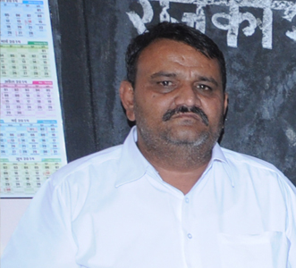
A village in Rajasthan celebrates by planting 111 trees every time a girl child is born. This was not the case till some years back. The village-in-question, Pipalantri in district Rajsamand in Rajasthan is about 70 km from Udaipur. Following its own brand of eco-feminism, it has successfully planted over a quarter million trees in the last six years.
This started with an idea by Shyam Sundar Paliwal, then sarpanch of the district. His entire family has been involved in social work from women’s rights to environmental conservation. Inspired by his father, Bhanwar Lalji Paliwal, he is particularly drawn to saving the girl child since losing his young 19-year old daughter during his tenure as the sarpanch.
As per the scheme active currently, a sum of Rs. 21,000 is collected from the residents and Rs. 10,000 from a girl's father. The total amount is put in a fixed deposit account opened in the girl’s name with a maturity period of 20 years. Besides, the girl’s parents are made to sign an affidavit promising that they would not marry her off before the legal age, send her to school regularly and take care of the trees planted in her name.
With his social activist father, wife as a member of Jila Parishad, work-personal life balance has never been a problem for him. He has received much accolades for his initiative and featured in media from across the globe. Raising funds is hardly a problem for him. He says, “I receive funds from organizations like you which help a lot to carry forward activities. Also industrialists and other fund providers help me lot for social activities. As fund providers feels that there fund is getting used for proper activity.”

Mr. Paliwal believes that dedication and will-power is a must for any dream to bear fruits. According to him, when one pursues their passion for work, nothing is difficult. In this respect, he urges all Indian citizens to work in their field of interest and government to support their initiatives.
He personally feels that in India, a lot of water gets wasted and so wants the government to conserve water by water harvesting which can then be utilized by farmers and in turn, increases returns. In addition, he wants the government to initiate some scheme to improve the life of the girl child and wants the government to initiate a similar scheme in all of India. He also urges the government to make environmental science and save girl child awareness education mandatory for all.
The village also plants 11 trees when someone dies. To prevent termite attack, this village of 8000 also plants aloe-vera plants which functions as a biopesticide around the trees. Now, they are a source of additional livelihood for several residents. “Now, residents make and market aloe vera products,” Mr. Paliwal concludes.
The progressive scheme that welcomes girl babies in Piplantri is having an impact on every part of the community. The village is greening its environment, changing attitudes toward women, reducing crime, and creating economic opportunity.
Profile of Nadeem Shehzad and Mohammad Saud
Since more than a decade now, this pair has been saving birds of prey on their rooftop-turned-shelter in Chawri Bazaar, old Delhi. Meet Nadeem Shehzad (36) and Mohammad Saud (32) who run a 24-hour bird rescue organisation that provides med¬ical treatment and shelter to predatory birds. The brothers started the service in 2003, when they found an injured black kite and took it to the Jain Bird Hospital in Chandni Chowk. But since the bird hospital was in a temple, they refused to treat injured carnivorous birds. So the brothers had the vet pay the bird home visits, and finally released it after it fully recovered.
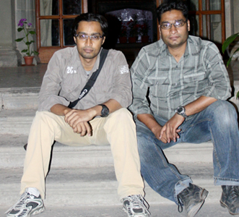
They were much amazed on “receiving the Sparrow Award since they work on Sparrow Hawks who eats Sparrows,” they joke. Their journey began out of a need for veterinary care for birds of prey and watching them die on the streets, uncared for. It has been more than a decade, but still, 95% of their efforts go out of their pockets.
Since that lone kite, they have sheltered, treated and looked after about 2,337 raptor birds such as owls, eagles, kites, hawks and the occasional endangered vulture. Even without any formal training, they have learned to fix bones using steel wires, stitch wounds using absorbable thread, perform complicated surgeries and even prescribe medicines simply by observing veterinarians over the years.
Funds are major concern for the brothers as their business is dying and professional lives are coming to an end because of their involvement with conservation. With their experience, they feel that “veterinarians do not have required knowledge on birds, so we did not have anyone to go and look for help. So it was no one except us who can perform surgeries to the wounded bird or watch it die. This made us expert surgeons in avian orthopedic surgery.”

Interestingly, without being veterinarians professionally, they have managed to learn to treat the birds through books and consulting doctors. They run family business of making metallic soap dispensers and fountain nozzles and manage funds from this. Today, many wildlife organizations call them for help every day! They can operate on the birds, stitch their wounds and heal them. With almost no monetary support, their motorcycle operates as an ambulance and the rooftop of their home as their 'little hospital'. They have already registered for a bird rescue organization, “Wildlife Rescue” and have launched 24X7 bird rescue helplines.
Although, their work has been covered by national and international media, Wipro-NFS Sparrow Award is their first award. Raising money is a major hurdle in their efforts and for them; the need of the hour is to make their organization self-sustaining so it keeps on functioning without their help. They believe that with no facility for birds of prey, it is their moral responsibility to do something for these birds.

They tell us that the fact that these birds will come to slow painful death without their help as it has nowhere to go and no one to take care keeps them going.“We want to start a proper rescue center with international standards,” they conclude.

The Winners can be contacted on their personal numbers:
Jag Mohan Garg - 09163340703
Mohammad and Nadeem - 09810129698
S S Paliwal - 09414172111

Functional Conservation initiatives undertaken by Nature Forever Society in past few months
Ban Chinese Manja campaign
Nature Forever Society launched a campaign against the use of Chinese or nylon or glass manja that kills many children, massacres birds and degrades local environment. We have begun this process by petitioning Veerappa Moily, Environment and Forest Minister of India. Individuals and organizations can sign this petition online (http://chn.ge/1klClqz) to show their allegiance.

As part of World Sparrow day celebrations, we urged citizens to write a message to the President of India asking for a ban on this lethal product. During WSd celebrations at Oberoi Mall, Mumbai, we collected almost 100 signatures on the same.

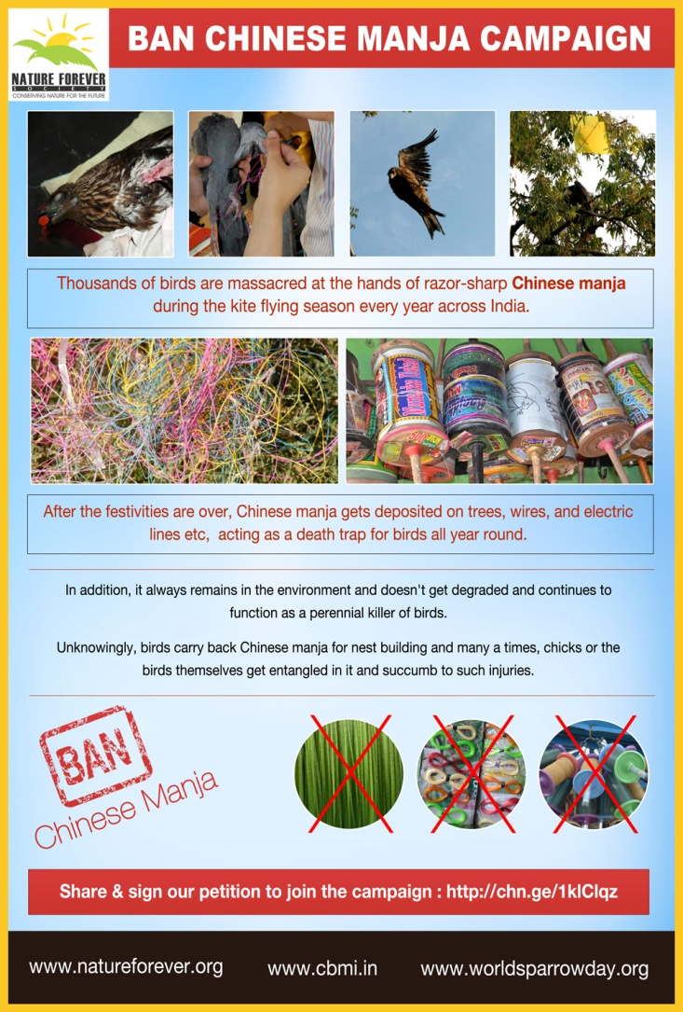

Campaign Background

Every year, the approach of Makar Sankranti (Harvest Festival) is a cause of concern for many bird conservationists, environmentalists and nature lovers. While reports of children deaths due to slitting of their necks across the country are heard, thousand of bird murders often go unreported. Consider for example, the case of Ahmedabad, the Uttarayan festival (annual Kite Festival of Gujrat) 2011 claimed eight lives, one of which was a four-year old girl whose throat was slit with Chinese dori despite a 2009 ban on its use for kite-flying. Nearly 300 more humans were injured. But no one counted how many (thousands) birds got injured or died. (http://bwcindia.org/Web/Awareness/Campaigns/KillerManja.html)

Chinese manja is made of glass nylon yarn with an abrasive coat of crushed glass that makes it razor sharp and life-threatening. In addition, it is non-biodegradable and shows semi-conductor behavior that further increases the chances of accidents, many of which are often unaccounted for.

In the past few years, state governments of Chennai, Ahmedabad, Mumbai, and Ludhiana have tried to impose a ban on Chinese manja but remained unsuccessful. Unless the Central Government come forward and impose rigorous punishments on the perpetrators who use the manja illegally, success cannot be achieved.

Once we have the backing of few thousand supporters, we plan on approaching the authorities at Wildlife Crime Control Bureau, Ministry of Environment & Forests and Forest Departments across states to take necessary action against the illegal buying/selling of Chinese manja. Also, we would utilize our resources in spreading awareness around this issue and urge citizens to employ cotton country-made manja that is non-abrasive, biodegradable and not a health hazard for birds and people.

Nurturing Nature
We celebrated International Women’s Day (March 8th) this year by featuring Indian women conservationists in a special magazine issue. Our motive behind this was to highlight their journey as professional conservationists, mothers, daughters and most importantly, as women.

Sentiments behind the issue

It’s often debated that the field of conservation is not the ideal work profile for women, especially in India, considering the amount of field work, travel and consequently, their security becoming a major concern. As the times are changing, so are the old notions and we are seeing newer crop of women conservationists fulfilling their dreams without inhibitions.

In this light, we endeavoured to reflect on the changing notions, bring together the experience of the past generation together with the vision of the future and find a way forward. It is our way of honoring the work of women conservationists and at the same time, inspires future generation of women conservationists.

The special issue is available to download from the home page of http://natureforever.org/

Please Visit our Social Media profiles for details:
Facebook: https://www.facebook.com/NatureForeverSociety
Twitter: http://www.twitter.com/NatureForever
Pinterest: http://www.pinterest.com/natureforever/
For further information contact
Nature Forever Society
Mohammed Dilawar
Ph – +91-9420001820
Oan Dilawar - +91-9890087988
Office - +91253-2411022
Email – info@worldsparrowday.org
Websites – www.worldsparrowday.org | www.cbmi.in |www.natureforever.org

For live updates visit www.facebook.com/NatureForeverSociety

Notes
- World Sparrow Day is not only about house sparrows. It includes all twenty six species of sparrows found in the world.
- The World Sparrow Day website has a photo gallery of 25 species of Sparrows. The only one missing is the Kordofan Sparrow (Passer cordofanicus), so if anyone has a photo, please contribute by sending it to the World Sparrow Day secretariat.
- For more information on Common Bird Monitoring of India, please visit http://cbmi.in/
- We welcome conservation organisations and invite them to support World Sparrow Day and to use its logos, website and aims as part of their ongoing work to save global nature.
- The World Sparrow Day secretariat welcomes feedback on how to be more effective. Please do send us your ideas and comments on novel ways to help sparrows.
- Please promote your activity on the world sparrow day website as it will help people discover how they can participate and link with other initiatives.
- World Sparrow Day is celebrated on March 20th annually. It is an initiative of the Nature Forever Society. In less than four years, this popular event has been celebrated in more than 50 countries around the world; including in Europe and parts of South Asia.
Nature Forever Society (NFS) has been working for the conservation of House Sparrows and other common flora and fauna for the past seven years. Its mission is to involve citizens in the conservation movement of India. To achieve this, NFS has been launching initiatives which are simple but have far reaching conservation value.
Mohammed Dilawar is one of the 30 most influential Heroes of the Environment chosen by Time magazine in 2008. He is a crusader for the almost ignored common sparrow. His efforts for the conservation of house sparrows are recognized both at the National and International level. He is the founder and President of Nature Forever Society and the brain behind World Sparrow Day, Adopt-a-nestbox and bird feeder campaign, BiodiverCity Photo Competition, Second-hand Binocular Scheme, NFS Sparrow Award and Help Birds in Summer Campaign.
He is a member of the International Working Group on urban sparrows; representing the Afro-Asian Region and has travelled widely across India to observe and photograph its wildlife and monitor conservation issues.

